Republic of the Philippines  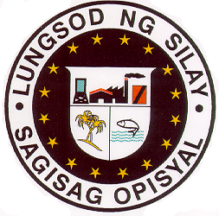  SILAY CITY GOVERNMENT  Zamora Street  Silay City, Negros Occidental  Telefax No. (034) 495-3746 | Control Reference Number : GOODS#0107, ITB#0108,  PR#0330: SCG-2020  Name of the Project: Purchase of Seeds and Fertilizers to be used in PLANT, PLANT, PLANT PROGRAM in the Office  of Department of Agriculture, Silay City.  Location of the Project : Department of Agriculture Office,  Silay City.

Standard Form Number: SF-GOODS-05
Revised on: July 28, 2004

INVITATION TO APPLY FOR ELIGIBILITY AND TO BID

The SILAY CITY GOVERNMENT, through its Bids and Awards Committee (BAC), invites suppliers/manufacturers/distributors to apply for eligibility and to bid for the hereunder project:

Name of Project | : | Purchase of Seeds and Fertilizers to be used in PLANT, PLANT, PLANT PROGRAM in the Office of Department of Agriculture, Silay City.
Location | : | Department of Agriculture Office, Silay City.
Brief Description | :
Approved Budget For the Contract | : | Php 198,390.00
Contract Duration | :
Delivery Period | :

Prospective bidders should have experience in undertaking a similar project with an amount of at least 25% of the proposed project for bidding. The Eligibility Check/Screening as well as the Preliminary Examination of Bids shall use non-discretionary “pass/fail” criteria. Post-qualification of the lowest calculated bid shall be conducted.

All particulars relative to Eligibility Statement and Screening, Bid Security, Performance Security, Pre-Bidding Conference(s), Evaluation of Bids, Post-Qualification and Award of Contract shall be governed by the pertinent provisions of R.A. 9184 and its Implementing Rules and Regulations (IRR).

The complete schedule of activities is listed, as follows:

 | BAC ACTIVITIES | SCHEDULE | TIME / VENUE
1 | Issuance of Bids Documents | June 1-8, 2020 | 8:00 AM – 2:30 PM Bids & Awards Committee Office
2 | Pre-bid Conference
3 | Dropping of Bids  Opening of Bids | June 8, 2020 (Monday)  June 8, 2020 (Monday) | 1:30-2:30PM (PST)  2:30 PM (PST)  Bids & Awards Committee Office, Silay City
4 | Bid Evaluation | IRR R.A.9184-Rule IX Sec.32.4
5 | Post Qualification, | IRR R.A.9184-Rule X Sec.34
6 | Notice of Awards | IRR R.A.9184-Rule XI Sec.37

Bid Documents will be available only to eligible bidders upon payment of a non-refundable amount of FIVE HUNDRED PESOS ONLY (Php 500.00) to the SILAY CITY GOVERNMENT Cashier.

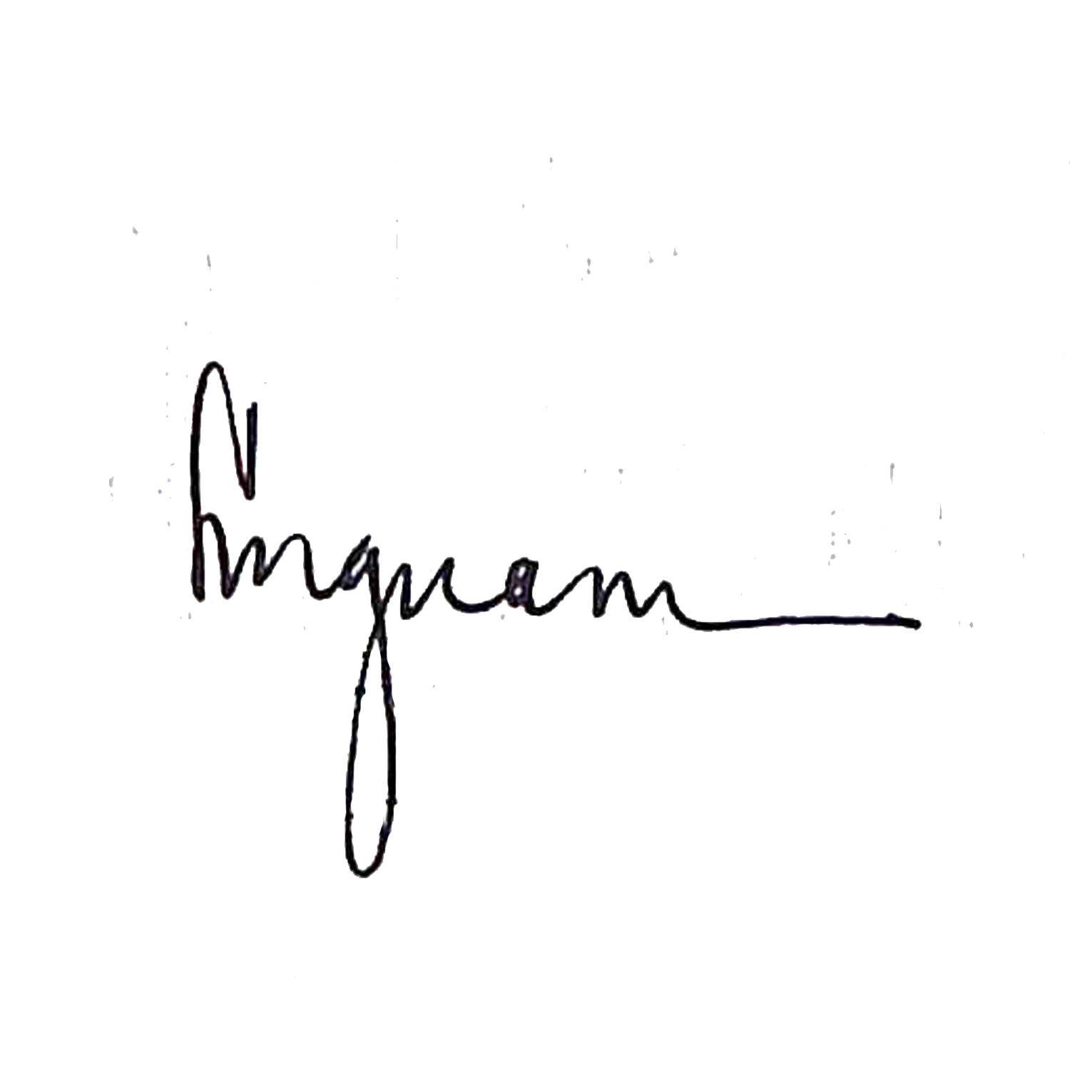
The SILAY CITY GOVERNMENT assumes no responsibility whatsoever to compensate or indemnify bidders for any expenses incurred in the preparation of the bids.

Approved by:

LORY M. GUANI
Head (BAC Secretariat) Bids & Awards Committee Office, Silay City.

Posting in Website : May 30-June 8, 2020

